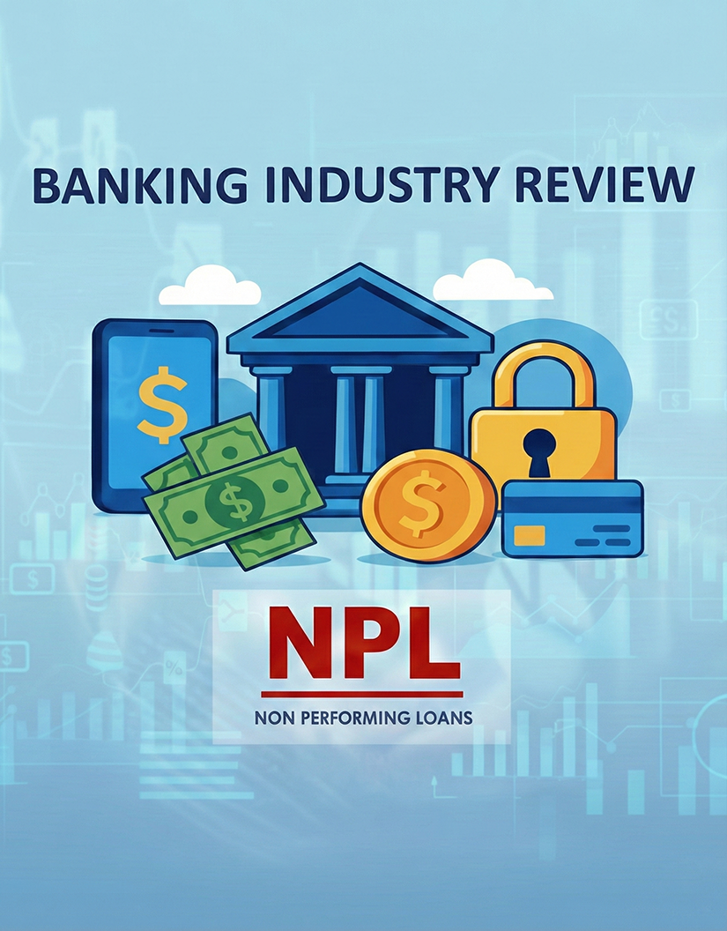

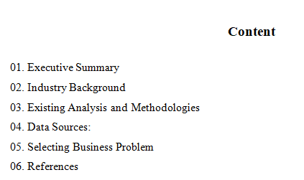

Executive Summary
As a developing country, Sri Lanka depends on its banking sector to support individuals and businesses. Therefore, identifying and addressing key issues is essential.
Report examines major challenges, including rising Non Performing Loans (NPLs), low marketing campaign success, and slow complaint resolution. After reviewing all, the project focuses on NPLs, as it has the strongest impact on bank’s performance and its stability. Predictive models will be used to identify which factors have the high impact for loan default, enabling banks to take accurate actions.

Industry Background
The banking plays an important role in economy by providing credit, supporting businesses, and strengthening household financial stability. With digitalization banks are under pressure due to rising customer expectations and growing credit and operational risks. In Sri Lanka, as a developing country, the banking sector is even more vital because it directly supports economic development. Hence it is essential to maintain stability of such an important industry.

Rising Non Performing Loans (NPL)

Problem 01 - What are the determinants most strongly predict the likelihood of a borrower becoming non performing, and how the bank use these insights to proactively identify high risk customers?

NPLs occur when borrowers fail to repay and weaken banks ability to repay the depositors money back. According to Saliba et al. (2023) “Among risk factors, credit risk, which is measured by the level of NPLs, is considered the most critical risk that threatens the overall stability of the banking sector.” Therefore, identifying the factors that cause customers to fall into NPL is essential.

Low Marketing Campaign Conversion Rates
Problem 02 – Which factors has strong influence to overall success rate through targeting the right customers for term deposits, while reducing cost?
Bank campaigns especially telephone campaigns often achieve very low success rates, regardless of high costs. According to Safarkhani and Moro (2020), banks invest heavily in marketing, but customers rarely respond positively. This leads to wasted time and inefficient use of marketing budgets.

Declining Satisfaction Due to Slow Complaint Resolution
Problem 03 - How does the speed of complaint resolution influence customer and how can the bank use these insights to improve service quality and reduce customer churn?
Today’s world with digitalization people expects quick solutions from banks. When complaints unresolved they switch to competitors. According to Guliyev and Tatoglu (2021), identifying customer churn enables banks to determine their characteristics and target them with better.

Existing Analysis and Methodologies
This section identifies how industry experts have analyzed and positioned these problems.

2.1 Non Performing Loans (NPL)
A large body of banking research examines drivers of NPLs which directly impact profitability. According to Nwafor and Nwafor (2023), the most influential factors for predicting NPLs include repayment progress and the remaining balance. Once data cleaned different learning techniques, namely, light gradient boosting method, random forest, decision tree and deep neural network applied.
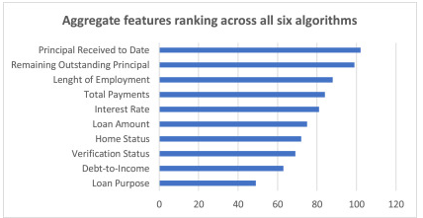

According to Maruf et al. (2024), behavioral factors like education, financial discipline influence default. The below graph shows probability of default when credit score improve.
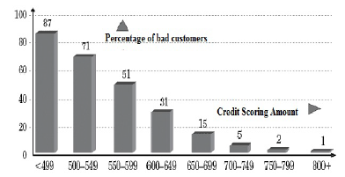
2.2 Low Marketing Campaign Conversion Rates
Safarkhani and Moro (2020) found that even banks invest in marketing, only a small percentage respond positively. According to El-Hajj and Pavlova (2023), figure 02 shows factors that most influence whether a customer responds to campaign.
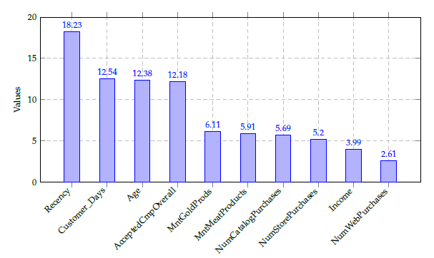
Moro et al. (2014) used a data collecting, mining, cleaning and predictive analytics methodology applied to a large bank telemarketing dataset. Their approach methods like Logistic Regression, decision trees etc

2.3 Slow Complaint Resolution
Baksi and Parida (2011) collected data through random sampling technique use Exploratory Factor Analysis. When customers perceive poor service quality their intention to switch increases. Both descriptive and Predictive techniques used in this study.

Data Sources
Data plays a central role in understanding customer behavior. This section shows data sources available to analyze industry and find reasons behind problems.

Dataset 1: NPL
Study uses a loan portfolio dataset from a Sri Lankan private bank operating across five branches in the as at 30.10.2025. The table consist few customers showing key variables.
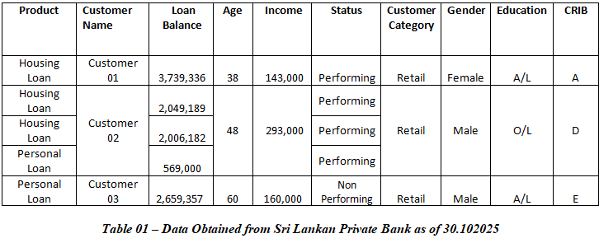
URL - https://github.com/1861360/Sri-Lankan-Bank-Data/tree/main
Nwafor and Nwafor (2023) used bar charts (Refer Figure 01) to summaries borrower characteristics. Also he used deep neural network approach as predictive analytic method. Apart from that logistic regression is used to estimate the probability of default. Decision Trees and Random Forest helps find which factors has high influence.

Dataset 2: Low Conversion Rates
To explore the problem, study uses UCI Dataset, collected from a Portuguese bank between 2008 and 2013. The dataset contains 41,188 records with below variables.
URL - https://archive.ics.uci.edu/dataset/222/bank+marketing

Descriptive Analytic techniques like bar charts, pie charts and trend graphs show relationships.

As a predictive analytics technique, logistic regression is used to estimate the likelihood that a customer will subscribe to a term deposit based on factors such as age, job type etc. Patel and Thakkar (2021) used random forest, gradient boosting and neural networks to identify the most important variables to outcomes.

Dataset 3: Complaint resolution
To explore the problem of declining customer satisfaction, this study uses the Banking Database, sourced from GitHub highlighting how service delays affect customer behavior with below variables.

According to Baksi and Parida (2011) use descriptive analysis likes Correlation analysis to show relationship between variables. Predictive Analytics help identifing customer churn using logistic regression, decision trees etc. Baksi and Parida (2011) use predictive analysis like regression analysis to show how independent variables influence a dependent variable.

URL - https://github.com/ahsan084/Banking-Dataset/blob/main/Comprehensive_Banking_Database.csv

4. Selecting Business Problem

4.1 Data Source
The analysis use loan portfolio dataset from Sri Lankan private bank, covering five branches in Greater Colombo region as at 30 October 2025. This dataset identify key variables.

4.2. Methodologies used and to be used
The dataset contained a few errors and missing values and those were corrected. The original data contained mixed credit rating formats such as A+, B+, D–, or C+. To avoid complication general categories A, B, C, D, and E, used for modeling credit risk.

Below techniques used to get an understanding of the dataset.
- This shows Business Medium customers has the highest NPL.
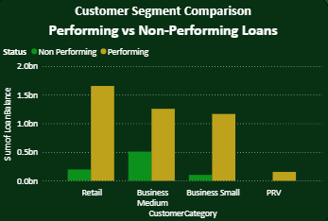
- Below pie chart shows in the loan portfolio highest value is with Business Loans.
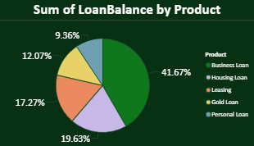
- Business medium customers show the poorest repayment discipline, appearing in CRIB rating E.
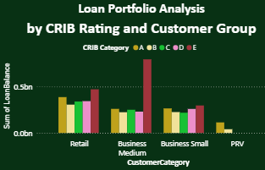

In next stage of project, predictive analytics methods such as logistic regression, decision trees, Random Forest, Support Vector Machines etc used to identify which factors increase the likelihood of a customer becoming non-performing.

4.3 Originality of the Contribution
Project provides contribution as,

The dataset is unique shows real customer behavior.

Project has practical value of identify risky borrowers and support accurate decisions.

To reduce future defaults.

References
- Nwafor, C.N. & Nwafor, O.Z., 2023. Determinants of non-performing loans: An explainable ensemble and deep neural network approach. Glasgow Caledonian University, United Kingdom.
- Maruf, A.A., Kowsar, M.M., Mohiuddin, M. & Mohna, H.A., 2024. Behavioral factors in loan default prediction: A literature review on psychological and socioeconomic risk indicators. American Journal of Advanced Technology and Engineering Solutions, 4(1), pp. 43–70. doi:10.63125/0jwtbn29.
- Saliba, C., Farmanesh, P. & Athari, S.A., 2023. Does country risk impact the banking sectors’ non-performing loans? Evidence from BRICS emerging economies. Financial Innovation, 9(86). doi:10.1186/s40854-023-00494-2.
- Safarkhani, F. & Moro, S., 2020. Improving the accuracy of predicting bank depositor’s behavior using a decision tree. Applied Sciences, 10(21), p.7480. doi:10.3390/app10217480.
- Guliyev, H. & Tatoğlu, F.Y., 2021. Customer churn analysis in the banking sector: Evidence from explainable machine learning models. Journal of Applied Microeconometrics (JAME),
- Moro, S., Cortez, P. & Rita, P., 2014. A data-driven approach to predict the success of bank telemarketing. Decision Support Systems, 62, pp.22–31.
- Patel, R. & Thakkar, A., 2021. Predicting term deposit subscription using ensemble machine learning models. Applied Computing and Informatics,
- Baksi, A.K. & Parida, B.B., 2011. Service quality and switching behavior of customers. Management Science Letters, 1, pp.405–414.
- Balakayeva, G. & Darkenbayev, D., 2020. The solution to the problem of processing big data using the example of assessing the solvency of borrowers. Journal of Theoretical and Applied Information Technology, 98(13), pp.1827–1839.
- Jovović, M., Mišnić, N., Pejović, B. & Mijušković, M., 2023. Customer satisfaction and switching intentions of banking services end-users in Montenegro. Journal of Central Banking Theory and Practice, 1, pp.45–56. doi:10.2478/jcbtp-2023-0003.
- El-Hajj, M. & Pavlova, M., 2023. Predictive modeling of customer response to marketing campaigns. Electronics, 12(3), pp.1–22. doi:10.3390/electronics12030512.

